Messaging Application for Tenant, Landlord and Agent in Ireland

Dissertation submitted in part fulfilment of the requirements

for the degree of

MSc I.S. with Computing

at Dublin Business School

Jigar Deepak Patel

MSc I.S. with Computing 2017-18

**Declaration**

I, Jigar Deepak Patel, declare that this research is my original work and that it has never been presented to any institution or university for the award of Degree or Diploma. In addition, I have referenced correctly all literature and sources used in this work and this this work is fully compliant with the Dublin Business School’s academic honesty policy.

Signed: _____________________________

Date: _______________________________

**Acknowledgement**

**Abstract**

**Content Page**

**List of Tables/Figures**

**Chapter 1**

1. **Introduction:**

In recent years, Ireland has encountered a great increase in the number of International students and it is one of the hottest destination to study abroad. As there are many famous universities and colleges like Dublin Business School, Trinity College Dublin, University College Dublin etc. and famous multinational companies like Google, Facebook, Apple, Dell, IBM and many other companies which attract students and professionals to come to Ireland for their career. There are a lot of other reasons like, English as a local speaking language, similar lifestyle like UK, work visas after graduation for example 2 years of work visas for Indian students, and no tension about Brexit (Istead, 2017). According to O'Brien (2017), there is a significant increase in the application of international students to Irish universities and most of them are non-EU. Universities has encountered increase in the number of applications in which University College Cork (UCC) had 40% and University College Dublin (UCD) had 26% of increase and non-EU students are mostly from the countries like India, China, United States of America and Canada (O'Brien, 2017). Since the number of students have increased, there will be a problem for them to search accommodation into their budget and time.

Currently, Ireland is facing housing crisis which is directly affected to the people looking to rent an apartment. The average time taken to find a proper accommodation in Ireland is usually between one to two months, but some may find it earlier. According to Lyons (2017), the rental market conditions showed by Daft.ie rental report in September 2017, was in bad state. The rent in other parts of the country has approximately risen by 45%, but at the same time, there was approximately 70% increase in rents in Dublin (Lyons, 2017). The reason to increase the rent at a faster rate is because of the lack of property supply, and in this situation, landlords will be in a great profit if they rent out their apartment. In the month of August 2017, property available to rent throughout Ireland were less than 3000 and was 20% down as compared to the previous year which happened for the first time in Ireland history. There were 4800 properties available to rent nationwide and almost half of the property was in Dublin at a time in early 2007 (Lyons, 2017). In 2017, there were roughly 1000 properties available to rent and that is because, the rent has increase by 50%. As this rental crisis was never known before, this will directly have linkage to the homelessness crisis which will eventually affect the students. In such crisis, if the tenants get an eviction notice from the agent or landlord, it is very difficult for tenants to search and shift into new apartment.

After a lot of difficulties in viewing of unaffordable and unacceptable apartments due to the housing crisis, the renter has found one apartment finally to move in. Even after finding the correct apartment, there are lot of issues in that apartment that you won’t be able to see through your naked eyes. To get those issues solved, the tenants should first contact his/her house agent and explain the problems, and then the agent will contact the owner of the house to seek permission whether to make any changes or repairs in the house. So basically, there is a communication gap between house tenants, agent and landlord. To overcome this communication gap between the house tenants, agent and landlord, this application can be used as a medium to report house related issues and convey the message to the correct person. This will help to save a lot of time and get the work done much quicker.

1. **Research Question:**

**How can we reduce the communication gap and housing problems faced by renters in Ireland using mobile messaging application?**

Through this research, my primary aim is to reduce the communication gap between the landlord, agent and tenants which leads to disputes between them and eventually eviction notice to tenants. The artefact implementation of this research will help all the renters regardless if they are international students or local renters to report house related problems like, if the window or window curtain rod is broken, plug point not working properly, heating system failure etc. to the owner of the house or agent directly using the user specific messaging mobile application. This mobile chat application will also be a medium for landlord, tenants and agents to solve the disputes between them. All the information regarding the Rights and Obligation for landlord and tenant, and dispute resolution information website links is added under HELP section, which will prevent all the users to go outside of the mobile application to hunt for information. There will also be an option for house agent or landlord to rate the tenants of the house according to their behavior.

1. **Practical benefits of the research and mobile chat application:**

* As this mobile chat application will help to reduce the communication gap between landlord, tenant and agent and help them to resolve any dispute.
* The house agent and owner can manage more than one house by creating separate groups and adding tenants in the respective house groups in one single mobile application.
* Tenant can only be added by the house agent in the respective group, as tenants can only stay in one house.
* As a tenant point of view, reporting house related problems by clicking picture is added on the chat application.
* Agent can upload legal documents of the house on the group with tenants and landlord included.
* Agent or owner can schedule meeting with the tenants through group chat.
* An agent can rate a tenant on the application according to his behavior or any issue. This will help eliminate the need of the reference letter from the previous agent or landlord and only agent can search the username of a tenant to check the rating.
* The websites links of Citizens Information is added in the application.

1. **Dissertation Roadmap:**

The Dissertation is divided into different chapters. First chapter illustrates an introduction and background of the dissertation and details the problem. Chapter two is about the literature review given below.

1. **Scope of the research:**

* This research is focused in designing and implementing a mobile chat application for Android operating system and focusing on specific users such as landlord, tenants and agent.
* The mobile application must be able to send, receive messages and, search and rate a specific user i.e. a tenant.
* This research will also provide information related to tenant and landlord law, effects of housing crisis on renters, and information regarding Threshold and Residential Tenancies Board (RTB).

1. **Limitation of the research:**

* The development of the mobile application is very vast and have several dimensions, it is very difficult to cover all the aspects of mobile development in a single research.
* Currently, there are many mobile Operating Systems (OS) like iOS, Android, Windows etc. available, so implementing the chat application for every OS is difficult.
* Posting a feedback for a user by another user is difficult and storing the feedback data in backend is also challenging. This feature will require more time to implement and will be available in version 2 of the application.
* As this research is regarding the chat app for landlord, agent and tenant. The main goal is to send and receive messages from specific users. Hence, End-to-End Encryption (E2EE) for the messages has been neglected and is beyond the scope of this research.
* For O-Authentication, I wanted to use SMS API, but the SMS packs or bundles from service providers are paid and hence couldn’t implement.

1. **Major contributions of this research:**

This research highlights the relationship between an agent, tenants and landlord. It discusses the effects of housing crisis, disputes and the need to resolve the communication gap between landlord, tenant and agents. It also discusses that, through the implementation of a mobile chat application, communication gap will decrease and hence there will be no cases filed to Residential Tenancies Board. It explains the practical benefits of the mobile chat application and there will be all the needed information for landlord and tenant in this research as well as mobile application. This research will ultimately contribute and improve the relationship between landlord, agent and tenants.

**Chapter 2**

**Literature Review:**

1. **Discussion regarding the Residential Tenancies Act of Landlord and Tenant Law:**

As this research is regarding the tenancy application, landlord and tenants should be aware of the basic laws and, amendments done to the previous Acts by the Residential Tenancies Board (RTB).

Currently, there is Residential Tenancies (Amendment) Act 2015 which has passed and signed into law on 4th December 2015 by the President (Baneham, 2015). Following are the amendments done to the previous Acts and stated in Act 2015 which are related to landlord and tenants.

1. **Rent Increase:**

Baneham (2015), a Barrister at Law has discussed and prepared all the changes made to the previous Acts 2004 to 2009. In the case of rent increase, landlord must inform the tenants 90 days’ prior regarding rent increase in a prescribed form. The prescribed form will include justification to increase rent and compare three advertisements of rent in same area four weeks prior to the notice given (Baneham, 2015).

1. **Termination of Tenancy:**

The base for tenancy termination is now very strict and stronger as compared to the Acts 2009 and 2004. The landlord needs to provide a termination or eviction letter in the case of tenant breach i.e. tenants in fault. Also, termination on the grounds of sale or occupying the apartment by landlord itself or any of his/her family member, landlord need to provide notice to tenants one month prior. And in the case of refurbishment of the apartment, landlord should re-offer tenancy to the tenants to stay in that apartment after the work is done in six months period (Baneham, 2015).

1. **Dispute Resolution:**

Residential Tenancies Act 2015 states additional categories for the issues that are related to dispute resolution. Additional category will include the failure of the landlord to return deposit amount to the tenants after their tenancy period. And failure of both the parties i.e. landlord and tenants to follow laws assigned to them (Baneham, 2015). The act also changes the cooling-off period of 21 days for resolution of the disputes to 10 days including weekends and bank holidays (Board, 2018).

The Planning and Development (Housing) and Residential Tenancies Act 2016 was passed and signed on 23rd of December 2016 by the President in which minor amendments are made to the Residential Tenancies Act 2004 which is related to both, landlord and tenants (Board, 2018). A landlord cannot terminate the lease contract or send eviction notice to vacant the apartment without any reason. If this happens, a tenant can lodge a complaint to RTB (Board, 2018). In the case of Anti-social behaviour by tenants, a landlord is liable to the distress caused to third-person (neighbour) (RTB, 2018). In Act 2016, which was changed on 9th May 2016, third-party i.e. affected person can now file a case against landlord and take the case to RTB. Other Act passed in 2016 related to landlord and tenant is Dispute Resolution. Telephone Mediation is a category in dispute resolution, which is now free (RTB, 2018).

1. **Doctor and Patient chat application in Android Operating System:**

In Sonwane, et al. (2017, pp. 170-174) shows that how doctor patient communication is done using the android chat application. In this research, the chat application is basically used for sharing data such as x-rays, ECG, blood reports, prescription etc. by the doctor with his/her patients. The implementation of this research shows that, the patient has to send request to the respective doctor, and then only communication is possible between them (Sonwane, et al., 2017), which is similar to this research.

In this research, specific users such as, tenants, landlord and agents will also be using a chat application to communicate between them. Like doctor patient application, in this research implementation, agent will be the primary user who can add landlord and tenants in a home chat group. Only if agent adds the tenant and landlord, then communication can happen over application. If there is no agent in between, the landlord can signup as agent and login in which he can manage all his/her houses. Sonwane, et al.(2017, pp. 170-174) uses technologies such as Firebase for backend and MySQL database to store information of the user. By this research, I found Firebase is used for all the back-end support for chat application which is simple and SDKs are already provided by Firebase. Also, user authentication i.e. OAUTH 2.0 is provided by firebase which will be automatically added when selecting an option. By this, the user can user Gmail or Facebook credentials to login to the app. Whereas in this research, all the users need additional information at first to sign-up, that’s why OAUTH cannot be used for sign-up in this application.

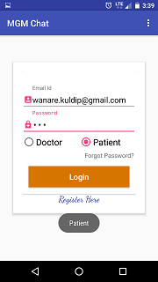

**Figure 1: Doctor-Patient Chat Login (Sonwane, et al., 2017)**

Figure 1 shows the login screenshot of the doctor patient application in which, the user must select either doctor or patient user type (Sonwane, et al., 2017). But there will be no extra information collected from the user at the time of login such as disease type and doctor’s specialty category etc. which will be need by the doctor at a later stage, as mentioned in limitations (Sonwane, et al., 2017). Comparing the research implementation of Sonwane, et al.(2017) to implementation requirements in this research, doctor-patient requires limited information while signup of the users, which is a drawback in future. Whereas, Renter Solution (name of my app) requires more details of the tenants, landlord and agents such as PSR (Property Services Regulatory) number of the agent, current address of the tenant and mobile number which is very important and hence won’t need any additional information in future. Also, there is a rating feature in the application where, an agent can rate tenants out of 5.

1. **Bluetooth based Android chatting application:**

The authors Mahajan, et al. (2014, pp. 712-717) shows that how a Bluetooth on an Android based smartphone can be used for chatting with another Android based smartphone. The author also explains that, most of communication happening is through China Unicom gateway which was paid service. To overcome this, author implements and used Bluetooth technology of an Android device to communicate with other smartphones having Bluetooth using the local area network, which help devices to communicate with each other without paying any cost (Mahajan, et al., 2014). The methodology used to implement is the Bluetooth module, where in the case of two devices connected via Bluetooth, one device will be Server and another device will be client or slave. Where there are more than two devices connected to each other, only one device will be server and rest will be clients and can only be added by server device or primary device (Mahajan, et al., 2014, pp. 712-717). The design of the chatting application is a Client-Server architecture. Bluetooth API is used where it provides RFCOMM (Radio Frequency Communication) channel to transmit data between the devices connected. Each Android device will have a unique MAC (Memory Access Control) address, and using this MAC address, the server-side device will be able to discover and pair the client-side Android device (Mahajan, et al., 2014, pp. 712-717).

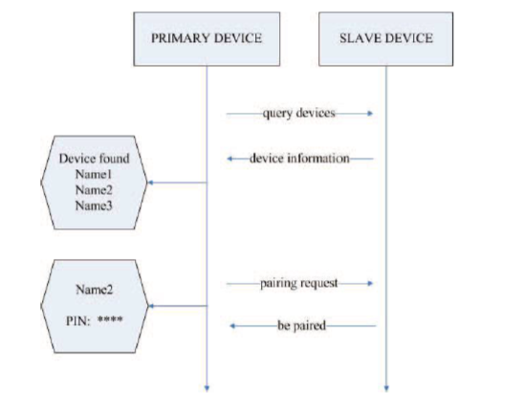

**Figure 2: Pairing process of the Bluetooth (Mahajan, et al., 2014, pp. 712-717)**

The author Mahajan, et al. (2014, pp. 712-717) explains the Bluetooth pairing process before establishing the chat session. Primary device i.e. Bluetooth server-side Android phone will enable Bluetooth and will be discoverable to other devices and can see all the slave devices with enabled Bluetooth. The server-device gets all the information of the available slave devices nearby and hence sending pairing request to device which it intends to communicate. The slave device will send a PIN number to primary device which has to match, if the PIN number matches then a connection is established between two devices where one device will be a server and other will be slave. Bluetooth communication is same as TCP (Transmission Control Protocol) traffic (Mahajan, et al., 2014, pp. 712-717).

Another research conducted by Ghare, et al. (2015, pp. 10674-10679) also shows how Bluetooth can be useful to chat with other devices. The research done by Mahajan, et al. (2014, pp. 712-717) and Ghare, et al. (2015, pp. 10674-10679) are similar to each other except for one feature i.e. chat history will be stored on a server which is done by Ghare, et al. (2015, pp. 10674-10679) in their research. The methodology used in both the researches are Bluetooth API’s which provides functions such as BLE (BT Low Energy) to scan other devices, Bluetooth Adaptor for enquiring paired Bluetooth devices and RFCOMM channel for establishing connection between the devices. The authors Ghare, et al. (2015, pp. 10674-10679) shows how an extra feature of saving the chat history to the remote cloud server, which can be used by a Bluetooth chat application. The authors use Android’s Backup Service to take the backup of the application through Backup Manager of Android, which queries about the backup data to the Bluetooth chat application. The only similarities of these researches to my research is that, they use Client-Server Architecture to communicate between the users of the application.

These Bluetooth based chatting systems are useful where there is no Wi-Fi or internet available, but it has several limitations (Ghare, et al., 2015, pp. 10674-10679). The limitations are:

* The maximum range of the Bluetooth is not more than 100 meters. This is a major disadvantage of Bluetooth based chat application where it cannot communicate with another user if they are far.
* Bluetooth chat applications can only transfer small amount data over chat.
* The speed of chatting will be slow as compared to other non-Bluetooth chat applications.
* In Bluetooth communication, any device enabled with its Bluetooth can get connected to the server device.
* The bandwidth of the Bluetooth technology is lower than Wi-Fi and cellular connections.

As compared to the implementation of my research, Renter Solution chat application will take out the limitations of a Bluetooth based Android chat application. Renter Solution is a Client-Server based architecture where communication between landlord, tenants and agents is not based on the Android Bluetooth. It relies on the cellular connection or Wi-fi to communicate with other users. Presently, cellular connection is very advanced and uses 3G/4G technologies which has worldwide coverage of the network. Hence, it provides faster data transfer rate as compared to Bluetooth. Also, almost all the users around the world has internet connectivity on their Android smartphones which eliminates all the users to be in any range and data transfer speed over the chat will be better. According to the reports of 2018 Global Digital suite from We Are Social and Hootsuite, the number of people around the using the Internet today are 4 billion (McDonald, 2018). In Renter Solution application, only the agent has been given right to add tenants and landlord of that apartment to the group chat. This will give assurance of no other stranger can get added to the apartment group unless he/she knows the agent or landlord.

1. **Intranet based chatting application:**

In this research, the authors Mehrotra, et al. (2014, pp. 265-272) discusses about the Peer-to-Peer (P2P) chat application used in an organization without the need of cellular network on Android smartphones and which are connected to the Intranet of an organization over Wi-Fi. The author shows that, in an organization where all the employees needs to have meeting at the end of the day or during the work hours, so they have to gather in a room or chat via email to share the work reports and discuss about the related projects (Mehrotra, et al., 2014, pp. 265-272). To avoid meeting physically or chat through emails, Mehrotra, et al. (2014, pp. 265-272) have proposed an idea of an Instant Messaging Android based application where more than one person can join the chat over internet which is connected to Wi-Fi in an organization. This Instant messaging chat application offers text-based quick transmission of messages from sender to receiver over intranet (Wi-Fi). The researcher uses BlueStacks App Player which is used to install and use Android applications on Windows PCs, Macintosh computers and Windows tablets by which all the users can use the application to chat with each other. The main aim of Mehrotra, et al. (2014, pp. 265-272) is to allow the users to communicate in an Intranet without paying any Internet data charge on Android phones. The architecture of the Instant messaging chat application is based on Peer-to-Peer (P2P) network and the developed service or application will be installed on the intranet server, through which all the users connected on the intranet can communicate with each other (Mehrotra, et al., 2014, pp. 265-272).

A similar study done by Verma, et al. (2013, pp. 1030-1032) says about the Intranet based messaging service on Android smartphones and tablets. It explains and demonstrate the implementation of their research. Following are the images of the implementation of Intranet Based Messaging service:

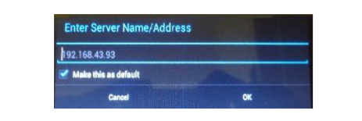

**Figure 3: Client interface (Verma, et al., 2013, pp. 1030-1032)**

The above image shows the client interface where the client specifies the server address, to connect with the organization server.

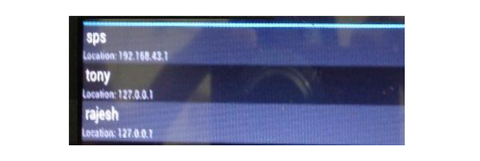

**Figure 4: List of active users on client side (Verma, et al., 2013, pp. 1030-1032)**

The above image shows when a client gets successfully connected to the server, the server broadcasts the list of active users and can communicate with other employees in the organization. All the information regarding the employees will already be stored in the organization server by the company (Verma, et al., 2013, pp. 1030-1032).

This research as compared to both the studies is not similar. The implementation of this research will be different, where the clients (users) i.e. tenants, landlord and agent will send request to the server and server will then give response to the request sent by the users. Which indicates that, Renter Solution chat application will not be bounded by the server in which all the users are connected through same Wi-Fi. The chat application of this research will work on Wi-Fi network as well as cellular network as compared with the Intranet based Messaging Service (Verma, et al., 2013, pp. 1030-1032) and Instant Messaging Service on Android smartphones (Mehrotra, et al., 2014, pp. 265-272).

1. **Comparison to existing chat application:**
2. **Introduction**:

As the number of smartphones users around the world has increased and it is expected to rise more. Today on a smartphone, a person can do the things that can be done on a laptop or desktop. Below is the image of number of the smartphone users around the world and prediction till the year 2020:

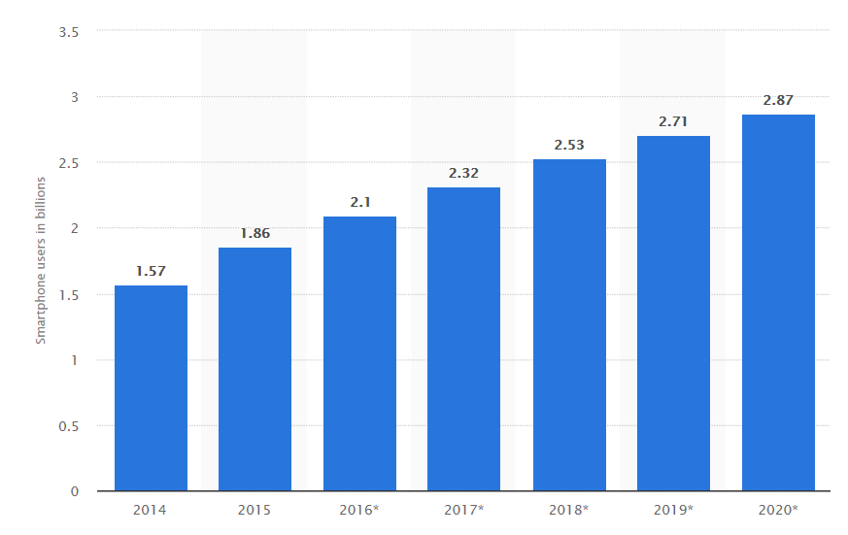

**Figure 5: Total number of smartphone users around the world 2014 to 2020 (Statista, 2016)**

As the above images shows the number of smartphone users around the world from the year 2014 to 2020. By the year 2019, the number of smartphone users is expected to grow around 2.71 billion and by 2020 it will grow around 2.87 billion (Statista, 2016).

Due to the increase of smartphones and users of smartphones, there are many applications developed for them. Since this research is regarding chat application, there are number of chat applications available in the mobile market to use. Earlier, every chat application was almost similar to each other but nowadays some chat applications in the market have started to differentiate themselves from other present chat applications.

1. **Existing chat application:**
2. **WhatsApp:**

WhatsApp messenger is one of the most popular cross-platform chatting application that is used to exchange text, voice call, video call, share location, document, audio and contact over iOS, Android, Blackberry and Windows smartphones (WhatsApp, 2018). The users of the WhatsApp are more than 1 billion in 180 countries around the world which helps family and friend to stay in touch anywhere and anytime in the world (WhatsApp, 2018). Below is the image of the chat interface of WhatsApp in Android smartphones.

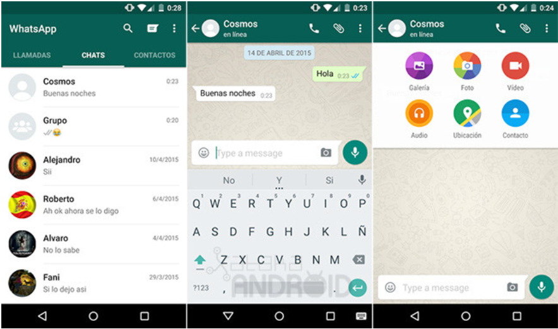

**Figure 6: Chat Interface (Phoneia, 2018)**

The chat interface of WhatsApp is very simple in design and user-friendly so that people can understand and use it easily. The protocols used by WhatsApp messenger are XMPP (Extensible Messaging and Presence Protocol) which is used for instant messaging between two or more users (Yasser, et al., 2017).

1. **Viber:**

Viber is a mobile chat application which provides endless options for expressing user’s mood through messaging and has variety of calling and messaging features (Viber, 2018). Viber supports video and audio recording, group chats, expressive stickers and, audio and video calls which can be used on iOS, Android, Windows phone and Windows10, Mac and Linux based devices (Viber, 2018). Below is the image of the chat interface of the Viber application:

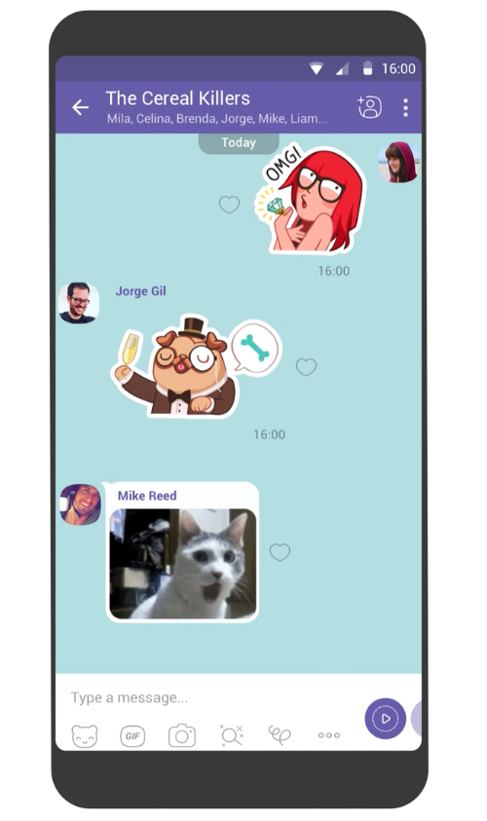

**Figure 7: Viber chat interface (Viber, 2018)**

The chat interface of Viber is unique and provides lot of options to express your mood. Various features of Viber are:

* The messages sent on Viber are End-to-End Encrypted which provides privacy to the application. You can hide a chat and access through PIN number, self-destruction messages and controls for when other see the status and delivery status of messages (Viber, 2018).
* Viber out is a feature that allows the user to call a non-Viber mobile or landline number from your contacts at very low rate. For that feature, the user must purchase Credit or Call plan (Viber, 2018).

The above feature makes Viber chat application stand out differently from other application in the market. The protocol used by Viber is VoIP (Voice over Internet Protocol) technology which allows the application to make high quality voice call by using broadband internet connection (Yasser, et al., 2017).

1. **Google Allo:**

Google Allo is also one of the most famous and popular chat messaging application in the market. Google Allo is available for iOS, Android devices and Web which can be used in any desktop or laptop. This application is developed by Google company and provides amazing features (Allo, 2018). Allo application has audio and video calls, audio and video recording, photo messaging and group chats (Allo, 2018) like existing chat applications. Below is the chat interface of Google Allo application:

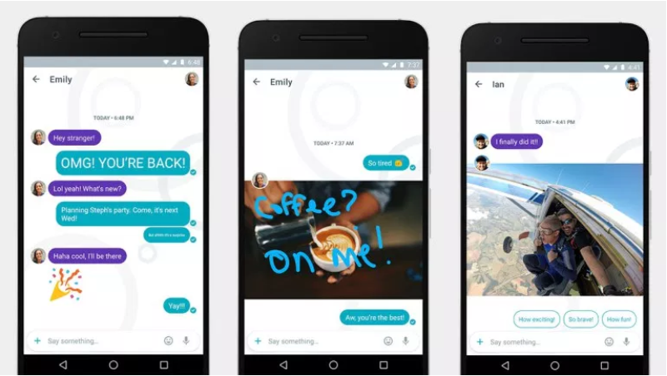

**Figure 8: Chat Interface of Google Allo (Miller, 2016)**

The user interface of this application is friendly and easy to use. Features that makes this application different from others are as follows:

* The user can respond without typing the message. Google Allo learns from the conversation and the way user texts (Allo, 2018).
* Allo has Google Assistant which helps the user whenever they need it. It helps you to stay in the conversation and search for things that the user wants to search (Allo, 2018).
* It has incognito mode in which all the messages are End-to-End encrypted and has self-destructive feature (Allo, 2018).

1. **Comparison to Renter Solution application:**

As there are many chat applications in the market, above are applications which are top 3 in the messaging business. The Renter Solution chat application is an implementation of this research study which is designed to be used by specific users such as tenants, landlord and agent only. This application will help all the users to communicate between each other and solve disputes. As the above mentioned can also be used for communication between the users of Renter Solution application, but there are certain features that make the Renter Solution application different from the top 3 chat application of 2018 as mentioned above. The implementation and interface related details are explained in Chapter 4 in this research.

The Renter Solution application does not include all the features of the mentioned chat applications, but it has features that are important related to this study.

* Renter solution application will only focus on specific users such as tenants, landlord and agent because main motive to develop the application is to reduce the communication gap between them.
* The other feature of the application will be that, it provides all the information that is related to the house, landlord, agent, and tenants.
* In the Help section, websites links are provided so that if the user is not sure or aware about his/her rights then, they can click the link and read it.
* Another feature is that, only agent has given right to create a chat group of a house, add tenants and landlord in that house group. If there is no agent dealing then, a landlord can signup as an agent.
* Only agent can rate tenants of the apartment according to their behavior. This rating feature will reduce and slowly eliminate the need of reference letter when a tenant is searching for a new apartment. The new agent can request username of the tenant to check the rating given by old agent.

1. **Aspects of Lease Agreement:**

Once a renter finalizes to move into an apartment after a lot of struggle, landlord will make sure that you sign the lease agreement which is very important. According to Whetsell & Airoldi (2018), a tenant should never rush through the process of signing all the documents unless and until he/she reads it carefully and should take an advice from any professional lawyer or family. Mark Hakim, an attorney in the real estate practice of Schwartz Sladkus Reich Greenberg Atlas says, *“In a market which favors the landlord, the renter will be stuck with what the landlord has to offer. In a softening market with high vacancies, renters will control negotiations ever so lightly.”* (Whetsell & Airoldi, 2018). Now, Ireland is a nation where the market is in favor of the landlord, and renter must agree what landlord will specify in lease agreement but before signing the documents, all the renter should know what they are signing for.

1. **Inclusions in Lease Agreement:**

The total rent of the house and rent due date as decided with the landlord, should be mentioned clearly (Whetsell & Airoldi, 2018). Some of the landlord in Ireland includes utilities such as electricity, Wi-Fi, and gas bills in monthly rent, which should be clearly stated in the lease agreement. If utilities are not included in the monthly rent then, the renter should be aware who is responsible for what (Whetsell & Airoldi, 2018). If the apartment is insured with insurance then, it should be specified in the agreement. Jeff Schneider, an apartment insurance broker says, *“The landlord’s insurance does not, despite what many people believe, cover the tenant,”* (Whetsell & Airoldi, 2018). The tenants will get their deposit back once their lease is finished but, the landlord or agent have the right to hold the security amount unless an inspection of the house is done. If any damage is found then, the money from the security deposit will be deducted regardless who did the damage (Whetsell & Airoldi, 2018).

1. **Invisible problems in apartment:**

According to Rogers (2018), before signing the lease agreement of the apartment, there may be serious issues in the apartment which are not visible to your eyes directly, unless and until you in that apartment. The issues might be drainage problem, electrical wiring, roofs, heating system failure etc. (Rogers, 2018). Especially if you are renting an apartment which is 30 - 40 years old then, there might be serious issues related to electrical wiring and plumbing. As the wires used before were aluminum which are prone to catch fire easily, drainage system leakage which can lead to cracks in the apartment foundation, clogged toilets which could arise serious plumbing problems (Rogers, 2018). If any such problems arise, make sure you contact your agent and landlord both to report such issues or it might result in deduction from your security deposit.

1. **Dispute Resolution Service:**

After struggling for accommodation, the renter will find a house that will fit in their budget but, there might be certain issues with landlord and agent. Following are the ways to resolve disputes between landlord, tenants, and agent.

1. **Citizens Information:**

According to Citizens(2018)**,** there are certain disputes between the landlord, agent and tenants during their tenancy period which will cause problems in long run. These disputes can be resolved between both the parties mutually, but if the issue is not able to solve mutually then a third party must get involved in the issue to solve it (Citizens, 2018). But before involving third party to solve the dispute, landlord and tenants both should be aware of the Rights and Obligations and must keep a record of facts that supports your complaint. If the dispute cannot be resolved mutually then a tenant can contact to:

* Threshold, the National Housing Charity, which provides information and advice to the people staying in rented apartments for any problems related to their tenancy period.
* If the rented apartment does not meet minimum standard requirements then, tenants can complain to Environment Health Service, which is responsible for houses in the private rented sector to meet minimum standard regulations for an apartment.
* You can complain to the Housing Department of local authority if the landlord fails to provide you the rent receipts.
* But if still dispute is not resolved then, you can take the case to the Residential Tenancies Board (RTB) (Citizens, 2018).

1. **Residential Tenancies Board (RTB):**

The main duties of the Residential Tenancies Board are:

* All the private residential tenancies and tenancies of approved house bodies are maintained in a register
* Provides a dispute resolution service for landlord and tenants if there are any issues between them
* Uses the data collected by registered tenancies to carry out research in the private rental sector (Citizens, 2017).

The Residential Tenancies Board is maintaining a national register of tenancies in which all the residential properties in the private sector must be registered by the landlord. If the landlord has not registered the property to the RTB then, the landlord will be incurred with penalties. All the Approved Housing Bodies (AHB) are also required to register existing and new tenancies with RTB (Citizens, 2017). Residential Tenancies Board will only provide dispute resolution service to the landlord if his/her property is registered. A tenant can lodge a complaint or opt for dispute resolution service even if their landlord is not registered the property with RTB. There are three ways to resolve a dispute between landlord and tenant:

1. Resolve the dispute mutually
2. Resolving by mediation
3. Resolving by adjudication (Citizens, 2017).

The rates to apply for adjudication is 15€ if you apply online and it will cost you 25€ if you want to appeal on paper. RTB will not charge you if you have applied for dispute resolution by mediation (Citizens, 2017).

1. **Complaints lodges to RTB:**

According to Ryan (2016), the number of complaints that has been lodged by the tenants against landlord for rent hike dispute has increased a lot in the middle of the worst housing crisis. According to the reports of the Residential Tenancies Board, there was an increase in the number of complaints logged by tenants for unfair rent hike by 70 percent as compared to previous year 2015 (Ryan, 2016). During the same period, there was also increase in the cases of illegal eviction by landlords on tenants. In 2014, Residential Tenancies Board dealt with 185 dispute cases that were only charging for rent higher than the current market rate, which in the year 2016 went to 313 cases. And in year 2017, during the first quarter of the year, number of cases already logged were 66 to Residential Tenancies Board (Ryan, 2016). But, there are number of tenants that does not lodge any complaint against landlord because they think, there will be time and money wastage. Threshold, a housing charity says*, “this is just the tip of the iceberg as most tenants do not lodge disputes with RTB”* (Ryan, 2016). In contrast, there are also many cases registered by the landlords against tenants who are denying to leave the house even if the lease agreement is over. In 2016, Residential Tenancies Board has registered 553 cases of disputes where tenants were defying eviction notices and, to the end of November 2017, the cases registered were 688 disputes which was 24.4 % increase in year 2017 as compared to previous year (Halpin, 2018). As landlords lodge complaint against tenant, RTB issues an eviction notice for the tenants which has to be followed. Halpin (2018) mentions that, many member of parliament has told the constituents to not issue an eviction notice to the tenants as, there is no place for them to shift unless and untill they find another house to stay. As these disputes are unpredictable, information regarding disputes and weblinks will be provided in the mobile application under Help section.

1. **Literature Conclusion:**

**Chapter 3**

**Research Methodology and Methods:**

1. **Introduction:**

The objectives of this research were to investigate and provide a solution to the problem arising in Ireland regarding the accommodation issues, disputes, and lack of communication between the landlords, tenants, and agents. To achieve these objectives, there was a need to investigate about the problems which were implemented in stages in the form of Questionnaires and Audio Interview.

The main reason to choose questionnaire for primary data collection method is considering the privacy of the people involved in survey and is an affordable option. Stage one of the data collection method was questionnaire which were targeted to renters, landlords and agents in Ireland through which, the researcher was only able to get 53 responses in which maximum were renters representing as International students. Second stage was taken into consideration when there was no reply from landlord and agents. After struggling, researcher managed to get an appointment from an Agent-cum-Landlord who owned and managed number of houses in Ireland. The interview was regarding the existing cases and problems faced by him. All the data collected from the questionnaire was analyzed using Microsoft Spreadsheet. The key to success to this research is to understand the perception of tenants who plays a major role in this research. As the questions used in the survey primarily focused on accommodation related issues and how were the issues solved which helped to determine the current level of relations between the actors.

This chapter will provide details about the methods used for research and why those methods were chosen.

1. **Research Design:**
2. **Philosophy of Research:**

According to Creswell (2009), design of the research is management of the procedures that are carried out for research which alters the decisions by broad view of hypothesis to detailed methods of data collection and data analysis. This will lead the researcher to decide and select a research design to be used for a topic. According to Holden & Lynch (2004), the research should not be methodologically driven, rather that methodology should be the significance of the investigation done by the researcher in the relevant area. With the investigation results, the researcher will get an idea of how to progress with implementation of the research according to the requirement (Holden & Lynch, 2004). Creswell (2009) explains that there are three types of approaches for an effective research named Qualitative, Quantitative and Mixed Methods. Qualitative research is used to acquire information from a group of people or individuals regarding their thoughts about a social or human problem. Quantitative research is used to acquire information from a specific instrument that are numerical, or statistical, or from computational techniques. Mixed Methods is an approach that gathers information by combining both quantitative and qualitative techniques (Creswell, 2009).

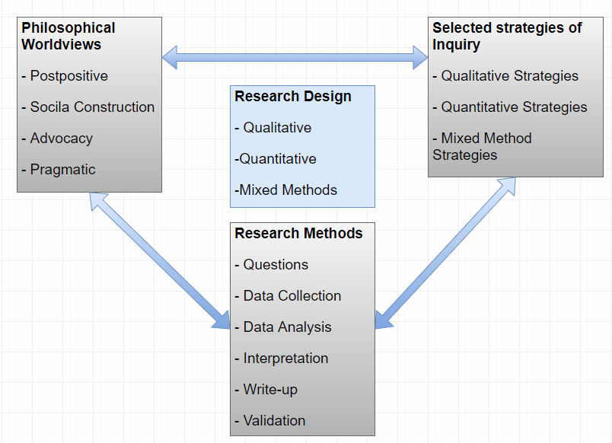

**Figure 9: A framework for Research Design**

The above figure illustrates the philosophical worldview of what the researcher make assumptions about the study, strategies to use for data collection related to the philosophical worldview and what procedures of research are being used to analyze and translate that into meaningful data related to the study (Creswell, 2009). There are four types of Philosophical Worldviews named Postpositivism, Constructivism, Advocacy/Participatory and Pragmatism.

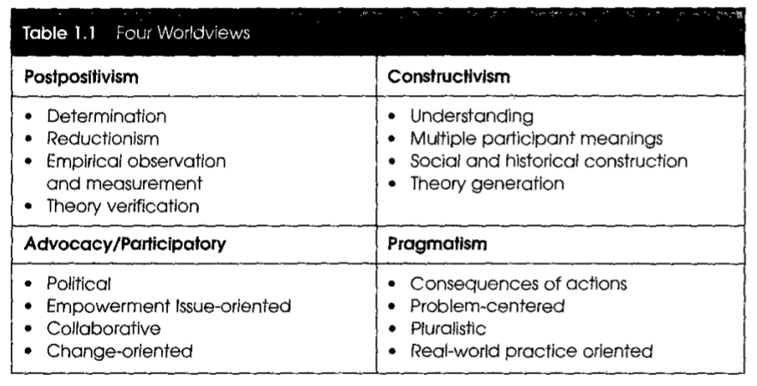

**Figure 10: Types of Worldviews (Creswell, 2009)**

The Research Design used in this study is Pragmatism. Pragmatism Worldviews is dealing with the actual problems in real-world and providing solution to that problem by the means of research approaches used (Creswell, 2009). The research strategy used in this research will be Qualitative i.e. questionnaire and audio interview. Questionnaire will provide information of what are the scenarios in real-world between landlord, agents, and tenants. And audio interview will provide the perception of an agent to the problems.

1. **Research Approach:**

The research approach used in this study is inductive. The researcher will start by collecting thorough information from a group of people or individuals related to the study and then divides the information into certain categories (Creswell, 2009). This inductive approach is following bottom-up approach. In this research, the researcher will first collect the information by interviews and questionnaire targeting the people related to this study. Once the data is collected, researcher will analyze and recognize a broad pattern from that data. Using that pattern, the researcher will develop a tentative hypothesis of the study. The researcher will finally craft the theory and conclusion of the study based upon the hypothesis. Below is the diagram of bottom up inductive approach followed in this research.

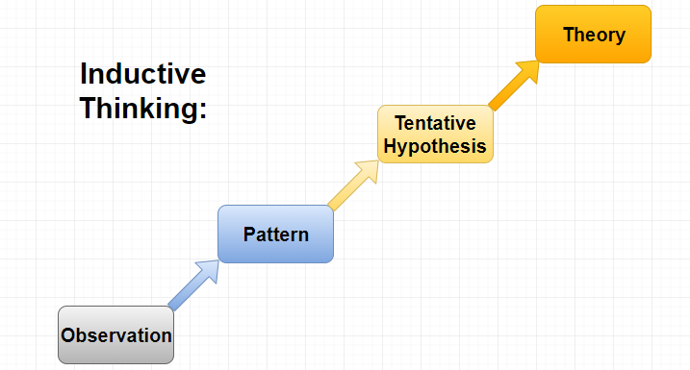

**Figure 11: Inductive Approach (Rubio, 2015)**

1. **Strategy of Research:**

There are two main strategies used in this research to gather information. The subsection will show how the data was collected and which strategy was used.

1. **Questionnaire:**

For the survey, Google Forms were used to gather data from the targeted audience in the form of questionnaire. The questionnaire was directed toward the tenants, agent, and landlord in Ireland and was circulated through social media. Below is the description of the question used in questionnaire.

**Question one to four** are “category” questions, where it asks about personal information of the respondents like their name, age, gender, and country of origin. This will help researcher to categorize respondents among the country of origin and age lines.

**Question five** is a “close-ended” question, where it asks the respondents whether he/she is an International Student (Renter), agent, or landlord. This will help the researcher to categorize between renter, agent, and landlord.

**Question six and seven** are “close-ended” question, where it requests international students to provide information regarding the University they study in and city of residence in Ireland. This will help the research to know, from which part of Ireland is the respondent from.

**Question eight** is “close-ended” question, that gives details of since when the respondent is residing in Ireland. This will give an idea to researcher, whether he/she is used to the culture in Ireland.

**Question nine** is “list” question type, where it asks information regarding respondent’s mobile operating system type. According to this, the researcher will get an idea of most used mobile operating system.

**Question ten** is “open-ended” question, which sought information regarding the time taken to find an accommodation.

**Question eleven** is “close-ended” question, where it asks about any problems faced during tenancy period. And if the respondent has selected “Yes”, then question twelve will request about the experience. This will help the researcher to get to know about the issues in the real-world and seriousness of the issue.

**Question thirteen and fourteen** are “close-ended” questions, which sought information about who manages the apartment and if there is an issue who will be the first point of contact. This will give an idea to researcher of who is most involved in managing the apartment.

**Question fifteen** is “list” question type, where it asks about information regarding the maintenance of the apartment.

**Question sixteen** is “open-ended” question type, where it asks about the actions taken by respondent regarding the issue.

**Question seventeen** and eighteen are “situational” question type, where it asks respondents, if they are in a situation then what actions he/she would take.

**Question nineteen** is “close-ended” question, which asks about the communication gap during tenancy period. And question twenty is “open-ended” question, where if the respondents have answered “Yes” then, they are requested to share their experience.

**Question twenty-one to twenty-three** are a type of question which asks the respondents about any relevant Messaging app they have used in past and experience using that application.

**Question twenty-four and twenty-six** are “close ended” questions, which sought reviews regarding the Mobile Application implementation of this research. This will help the researcher to develop the application according to the real-world scenarios and need of the major actors in this study.

**Question twenty-seven** is “close-ended” question and question twenty-eight is “open-ended” question, where it asks about the agent regarding house repairs. And twenty-eighth question requests to share the experience of the respondent if answered “Yes”.

**Question twenty-nine** is “rating” question type, which asks about the application developed for this research will be useful or not.

**Question thirty** is “open-ended” question type, where it asks suggestion for the features used in Renter Solution messaging application to the respondents and review.

1. **Audio Interview:**

Audio interview was conducted with an Agent cum Landlord, when there was no response from any landlord or agent through the questionnaire circulated.

**Question one** asked will give the information of how many houses are controlled and owned by the agent. The interview taken from the person represents a group of agents and landlords, which will help researcher to get an instinct of the real situations.

**Question two** is an “open-ended” question type which asks about communication gap between the major actors in this study.

**Question three and four** asked have enlighten the disputes between the actors. By this, the researcher will get to know the perception of an agent and landlord towards the disputes and the way to solve them.

**Question five** asked whether the application developed for this research be useful for them or not.

1. **Limitations of Methodology:**

As the method used for collecting the data through Google Survey, there were lot of difficulties that a researcher has faced. Below are the details of it:

* As the method used for collecting data, the questionnaire was circulated through social media targeting landlord, agent, and tenants. The researcher majorly got response from the tenants and only few were agents. The landlord and agents were not available for most of the time.
* Taking an appointment from a landlord for an audio interview was a big task. After requesting number of times, one of the landlords cum agent was ready for the interview.

**Chapter 4**

**Artefact Design and Implementation:**

1. **Introduction:**

The main aim of this chapter is to display all the development stages of the Renter Solution mobile application from beginning and the design of the application. This was achieved using Android Studio software, through which prototype of the application was developed to serve the purpose of a chat interface to specific users. The reason behind using Android Studio are simple integration between the tools, user interface gives best experience to programmers, provides complete tutorial, supports emulators, debuggers and provides with the latest updates (Xcommunity, 2017). The programming language used for the development of chat application in Android Studio are Java and J2EE which are used for the effective communication from the server and the application, PHP (Hypertext Preprocessor) which was earlier know as Personal Home Page which is used for all the background processes, XML (Extensible Markup Language) which is used to design the layout and interface of the application and, the database used is MySQL database which is easy to create a relationship between the entities.

As the research question of this study is to reduce the housing problems between the landlord, agent, and tenants by implementing the chat interface, so this chapter will include the design of the chat interface in Android and it describes the overall approach of implementing the chat application. This chapter has four sections in which, first chapter will describe about the software development life cycle (SDLC) model, second section will describe about requirements of the application, third section will describe about the design and last section will give implementation details.

1. **Software Development Life Cycle (SDLC):**

A software process is a set of combined related activities that help for the development of the software (Gabry, 2017). These combined activities might include building a software from the start, or, customizing the existing software. There are certain activities that a software process must include:

1. Requirement gathering or specification
2. Design and implementation of the software
3. Verification and Validation of the software
4. Maintenance of the software (Gabry, 2017)

The process model selected was Prototyping Model for developing Renter Solution Android application. According to Pressman (2010, pp. 42-44), Prototyping is model which is a version of a system that is developed quickly according to the requirements of the software. Prototype model is useful when the requirements of the function are not defined in detail. The paradigm of the prototype guides the developer and targeted users to better understand the application when the requirements are fuzzy (Pressman, 2010, pp. 42-44).

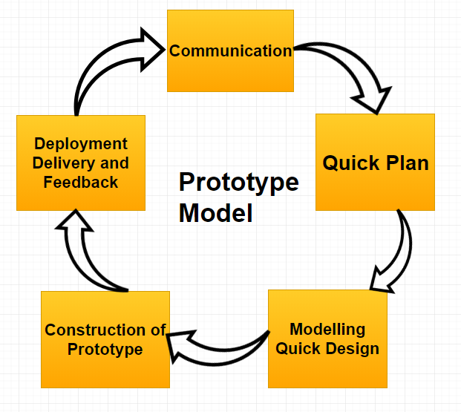

**Figure 12: Prototype Model**

The figure shows the prototype model processes. In this research, the process begins with communication with the targeted audience i.e. landlord, agent, and tenants. By getting to know the issues between them, requirements of the application were known. After knowing the requirements of the application, a quick plan was documented which is the application specifications. With the help of the existing chat application in the market, a quick design of the application was described. Once the requirements, design and specifications of the application was known, a prototype was constructed. As the application was built on Android, the application (.apk) file was circulated to the users, by which the feedback of the application was known. During the development of first few prototypes, there were many changes made to the application according to the feedback from the users. As full process was iterative, finally a final version of the application was decided and deployed.

1. **Prototype model advantages:**

The prototype model has several advantages in the software development. The users are involved in the development process from the beginning. Since the working application will be demonstrated, the users will get an idea of the software. Errors can be detected at an early stage of development which will deduct the cost and time. User feedback is very quick that will help to resolve the bugs. Any missing functionalities in the software can be identified and can be implemented (Point, 2018).

1. **Prototype model disadvantages:**

There are also certain disadvantages of this model. If the requirements of the users are not clear then, the application developed can be at risk. In a scenario where, large system must be developed, the complexity of the actual system will increase as compared to the prototype. There might be a confusion with the users between prototype and actual requirement (Point, 2018).

1. **Requirements:**

The main goal of this section is to define the functional and non-functional requirements of the Renter Solution chat application. For any software development, requirements analysis is very important. Without analyzing the requirements of the software, the application might be of no use to the targeted users. “*A requirement is a necessary attribute in a system, a statement that identifies a capability, characteristics, or quality factor of a system in order for it to have value and utility to a customer or user.*” Young (2004). In many industries, for a system development, insufficient time is spent on requirement related activities (Young, 2004). As per Young (2004), it is always better to spend more time on requirements gathering which will help the developers to design and implement the application. In this research implementation, requirement gathering was done and data was analyzed through the process explained in Research Methodology chapter.

1. **Functional Requirements:**

The functional requirements describe the functionalities of the software i.e. what an application should do (Young, 2004). Functional requirements are also known as behavioral or operational requirements because they specify the input, output, and relation between them (Young, 2004).

1. **Signup:**

This requirement should ask every user with the option to signup by prompting name, username, gender, password, email, age, date of birth and mobile number. Once the user finishes signup, app should take on the login page.

1. **Login:**

This requirement will ask for Username and Password. If the user has already registered previously, the information of the user should be saved in the database in a server. If the username and password is incorrect, it should display “Invalid username or password”.

1. **Type of User:**

The Renter Solution chat application should ask the user-type i.e. tenant, landlord, or agent before signup. According to the user-type, the signup form should display. For agent, without adding PSR (Property Services Regulatory) number, signup should not proceed. And for tenant, without specifying the current address (if renting for first time then should specify home country address), signup should not proceed. For landlord, the signup process is normal.

1. **Logout:**

By clicking on the logout button, the user should be logged out and application should take user to login page.

1. **Chat group display according to user:**

The chat application should display the chat groups on the Home screen according to the user if he/she is added in any group by the agent. Only agent can create chat groups, add tenants, and landlord in the application.

1. **Chat:**

In this functional requirement, the user should be able to send and receive messages on the group.

1. **Search:**

This aspect of the requirement should allow every user in the application to search other user by their username who are registered.

1. **Rate another user:**

This functionality is the most important function which makes this application different from other existing applications. This aspect will allow all the user to rate other users according to the behavior of landlord, agent, and tenants.

1. **Non-functional Requirements:**

Non-functional requirements specify system properties which can be used to judge the system operation.

1. **User-friendly:**

The application should be very simple to use but unique. The user should be able to navigate from one section to another section without any difficulty.

1. **Availability:**

The application can be uploaded on the Google Play-Store, so that it can be available on every Android operating system device. As the number of android user today are much greater than the number of different operating systems.

1. **Scalability:**

As the number of the users might increase because of the popularity, the server capacity can be upgraded which will be able to handle a greater number of users.

1. **Performance:**

The experience of the user should be smooth throughout the app. This can be achieved by efficiency in chat message delivery, uploading a picture through camera.

1. **Affordability:**

As the android smartphones are very cheap and available throughout Ireland, this can create great connectivity between the users. For example, if the tenants are staying in Dublin, and landlord is staying in Letterkenny which is in other part of Ireland, can still contact through this chat application.

1. **Minimum Android System Specification:**

* 1 Gigabyte RAM
* 4 Gigabyte system memory
* Android KitKat and above operating system

1. **Artefact Design:**
2. **Introduction:**

This section of the research will show the design of the Renter Solution chat application through system architecture, class, use-case, and sequence diagrams.

1. **System Architecture:**

An architecture of a system is like a blueprint of the system. According to Pressman (2010, pp. 243-245), the architecture of the system is a basic structure of the system which displays external properties of the components and relationship among them.

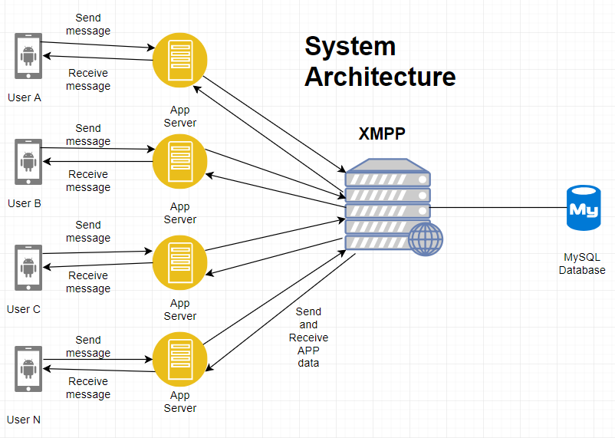

**Figure 13: Renter Solution System Architecture**

The above image illustrates the architecture of Renter Solution chat application which has several components in it. The user of the application will first login which will be validated from the MySQL database. XMPP (Extensible Messaging and Presence Protocol) is a set of technologies that are used for multi-party chats, instant messaging, light weight middleware and routing of XML data. It provides near real-time messages delivery for a chat interface to any other user over internet (XMPP, 2018). After the user has logged-in successfully, the web server will display the list of chat groups that a user is present in. For example, if User A send a message on a chat where User B is also present, the message will pass through the App server and then XMPP server. Then XMPP server will send that message to all the App server i.e. users present in a group and then delivered to mobile application.

1. **Use-case Diagram:**

A use-case diagram is used to show all the processes, actors, and relation between them in the software system (Dennis & Wixom, 2009, p. 517). Below is the Use-case diagram:

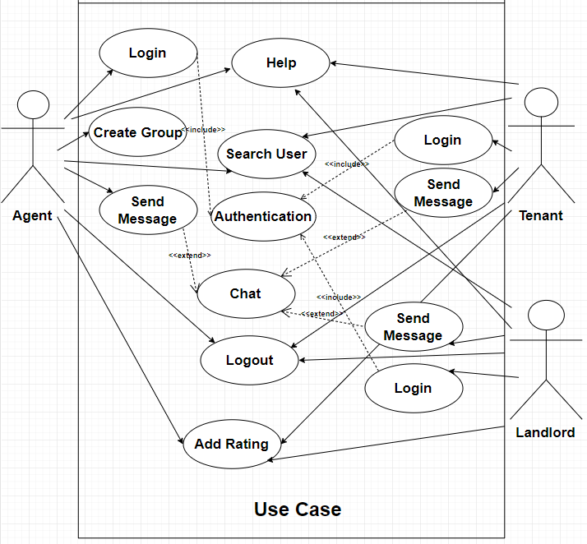

**Figure 14: Use-Case Diagram**

1. **Class Diagram:**

A class diagram is used to show all the classes used in the software application and relationship among the classes that stay constant in the software application (Dennis & Wixom, 2009, pp. 521-525). Below is the class diagram for Renter Solution application:

**Figure 15: Class Diagram**

1. **Sequence Diagram:**

The sequence diagram is even known as event diagrams. It depicts events, or the sequence of messages that are exchanged between the objects and classes that are included in the scenario (Dennis & Wixom, 2009). Below is the sequence diagram for Signup, Login, and Create group used in Renter Solution application.

**Figure 16: Sequence Diagram for Signup**

**Figure 17: Sequence Diagram for Login**

**Figure 18: Sequence Diagram for Create Group**

1. **Renter Solution App Layout design:**

For design layout of the application, XML has been used for designing the graphical user interface part of the application which is integrated with the Android Studio IDE (Integrated Development Environment).

* **Login interface:**

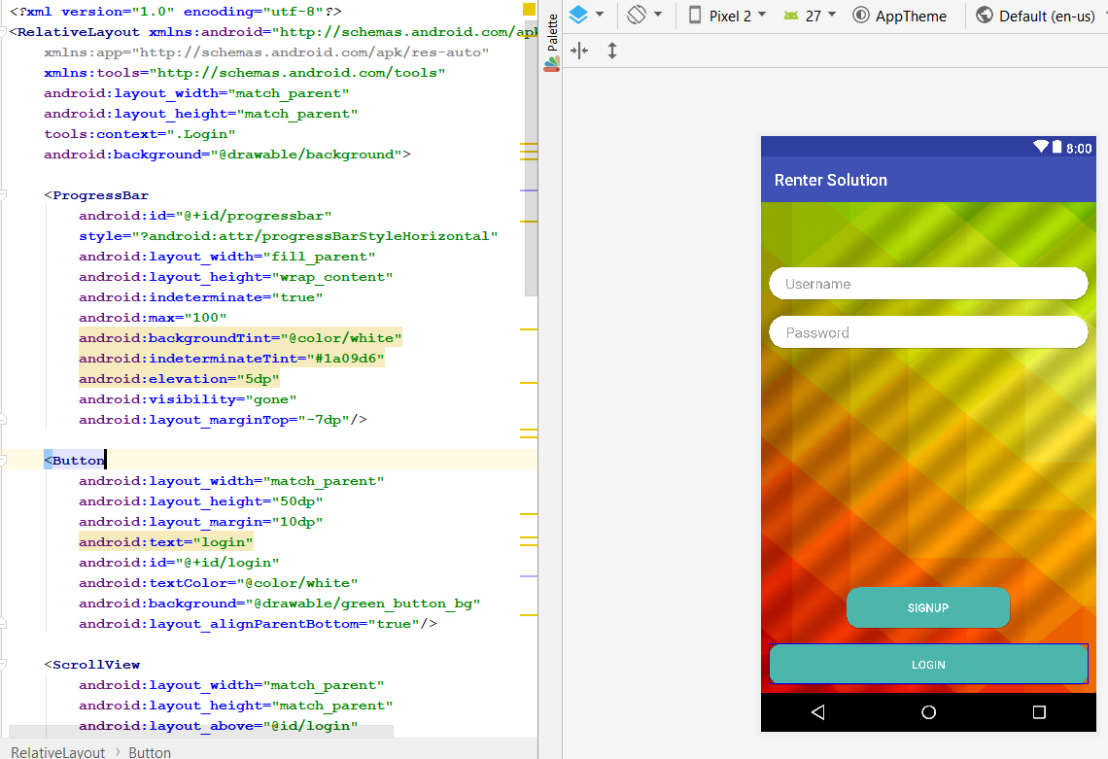

**Figure 19: Login Interface**

As the relative layout is which is very flexible layout to used in Android development which gives the flexibility to place component as per relative position (Developers, 2018). In the figure 19, two buttons and two edit text were created where, button represents signup and login and, edit text will offer user to enter username and password. The interface of the login page is very simple and user-friendly to use. The main logic implementation was coded in **“Login.java”.**

* **Signup Interface:**

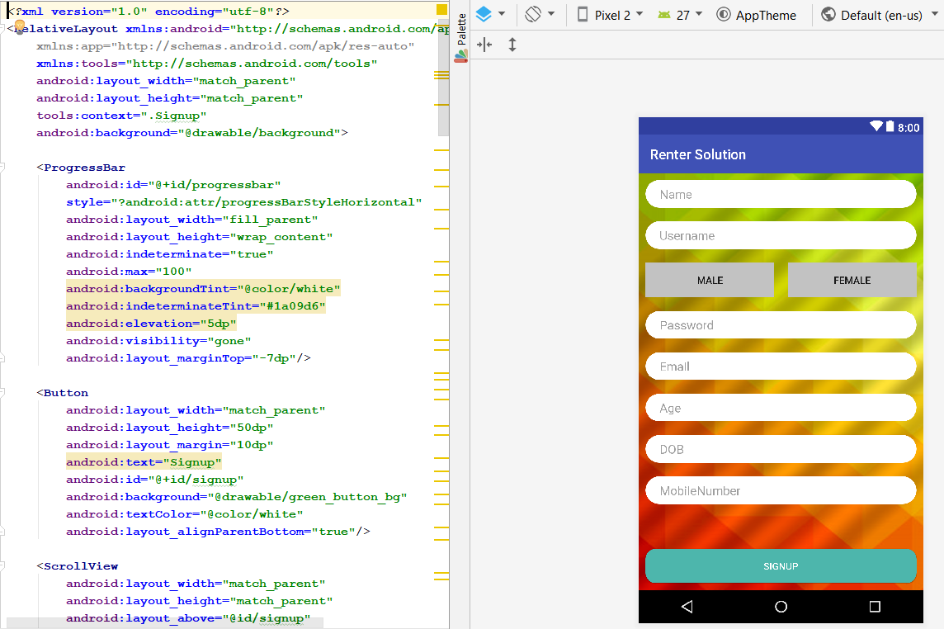

**Figure 20: Signup Interface**

For Signup interface, relative and linear layout was used to position various buttons and edit text. The signup interface has many fields, so scrollview is used for the users to scroll down for entering their details. The signup logic is coded in **“Signup.java”.**

* **Group Interface:**

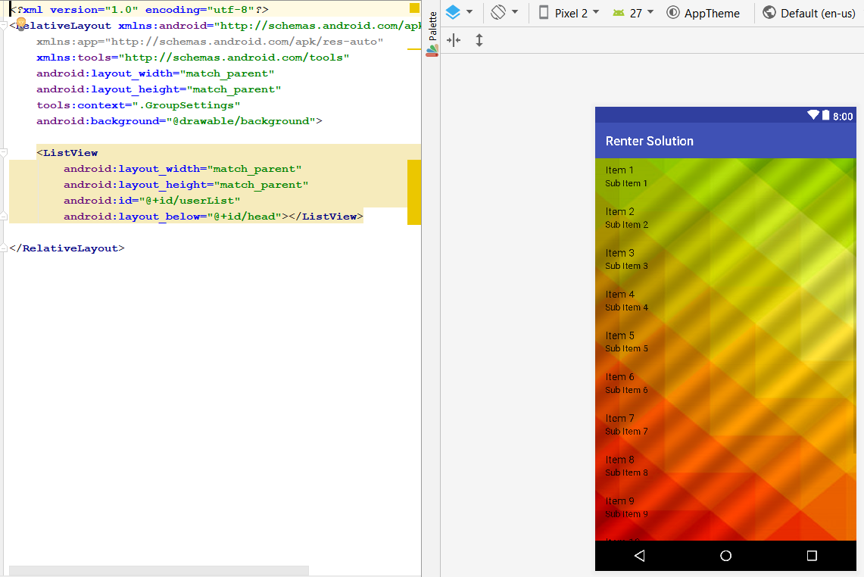

**Figure 21: Group Chat Display Interface**

The chat group interface contains relative layout in which, the groups will be displayed on the screen in list view to the user in which he/she is added. The main logic was coded in **“GroupSettings.java”.**

* **Help Interface:**

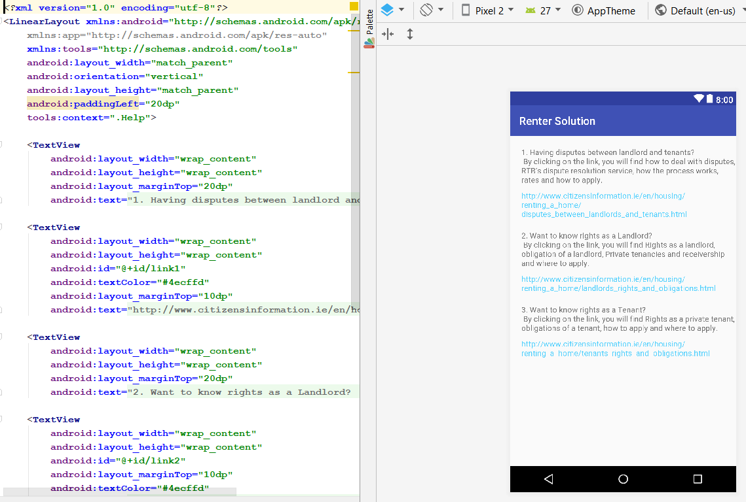

**Figure 22: Help Interface**

The layout used for help interface is linear. It displays the text followed with the website link for the users if they have any disputes etc. The logic was coded in **“Help.java”**.

* **Select User-type Interface:**

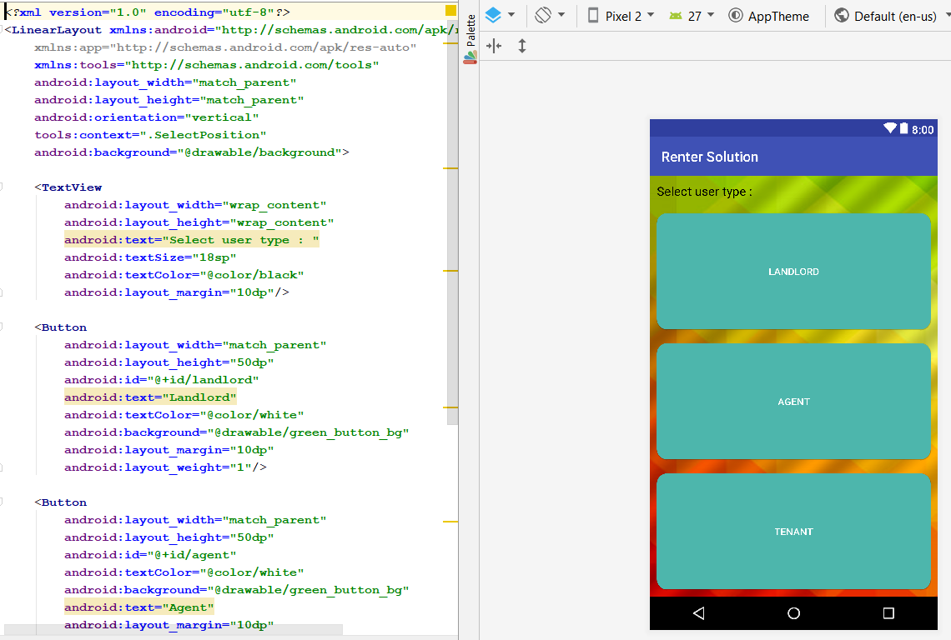

**Figure 23: User-type Selection Interface**

Foe the user-type interface, three buttons are used in a linear layout. New users will get this interface after pressing signup button. The logic was coded in **“SelectPosition.java”**.

* **User Profile Interface:**

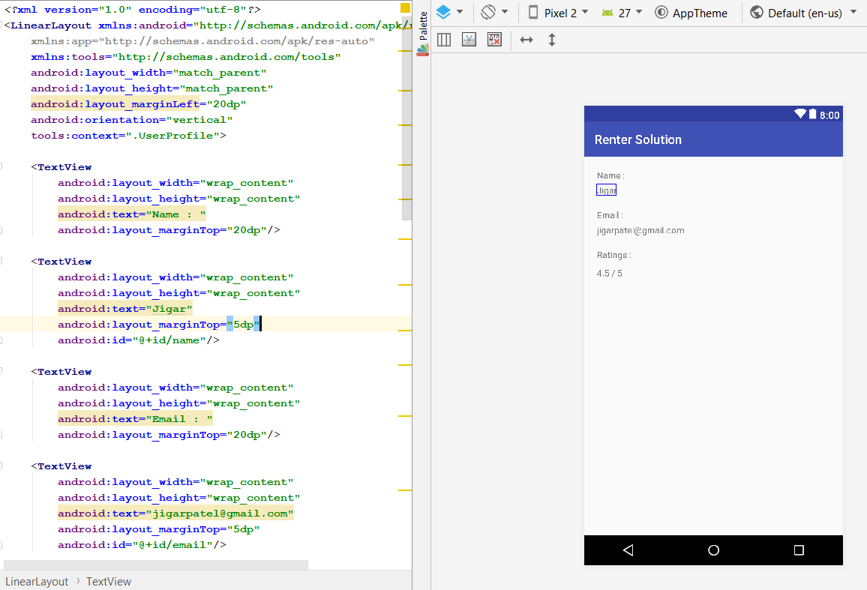

**Figure 24: User Profile Interface**

The interface of the user profile is kept very simple by displaying the name, email, and ratings of a user. The main logic was completed in **“UserProfile.java”.**

1. **Implementation of Artefact:**
2. **Introduction:**

This section gives a detailed description of implementation of prototype of rental solution chat application. This section is further divided into three subsections. First subsection will give a description of APIs that were developed and used in the development, second subsection will show the working of Renter Solution App.

1. **API:**

All the APIs’ that were used in this application is developed by the researcher and no any external or predefined API were used. All the APIs are created in PHP. Following are the list of the APIs’ developed and used:

* **addRatings.php**

With the help of POST method, rating is submitted to user when searched. The rating will be saved in the database.

* **Login.php**

When login form is submitted in POST method, the data is passed to the API and further it checks the data in the database. If username and password exist in the database, it will return required data such as user-position, name, and ID. If username and password doesn’t exist, it will return an error message.

* **Signup.php**

When signup form is submitted through POST method, the data is stored in the database using the signup API.

* **getUserList.php**

This API will be used to get the list of the users from the database which displays username and email.

* **getGroupList.php**

This API is used to retrieve all the groups in which users enrolled. After login, user_id is passed to the API (getGroupList), then API checks the user id for each group in the database and when it founds the group it will store it in array and return it to the main controller.

* **AddUserToGroup.php**

This API is used to add user to the group chat.

* **deleteUserFromGroup.php**

This API will delete a user from the group.

* **getUserDetails.php**

When a user enters a string in the search bar, this API contains a query which compares each string in the database that matches and returns the results which are Name, Email and Rating.

* **getData.php**

All the chat messages of the group are stored in text document with the time. When a user sends a text on the group, text document is appended, and the file is saved. This API will pull the text document and display on the user screen.

* **addGroup.php**

This API allows agent to add a new group that is saved in the database. Then the agent gets an option to add users such as tenant and landlord to the group.

* **GetGroupList.php**

This API will display the list of all the groups on the chat home screen in which the user is present.

1. **Working of Renter Solution Application:**

* **Login Page:**

This is the first page (view) that user will get when he/she runs the application. In this page, the user will ask for username and password. After submitting username and password, it will verify the username and password. The verification is done using login.php API. If the user is not registered with the App before, it will show signup option to the user. If user login credentials are correct, then it will show next view, otherwise it will show an error massage “Invalid Username or Password”. Figure **25** shows the login page:

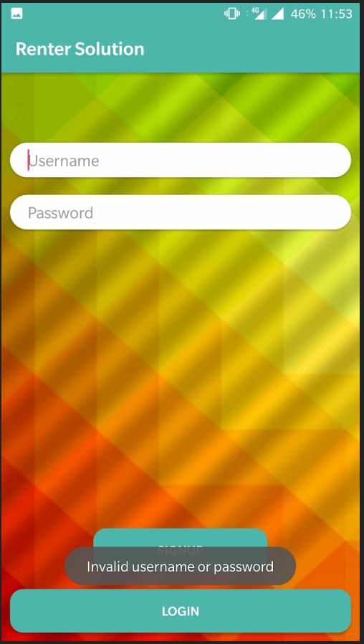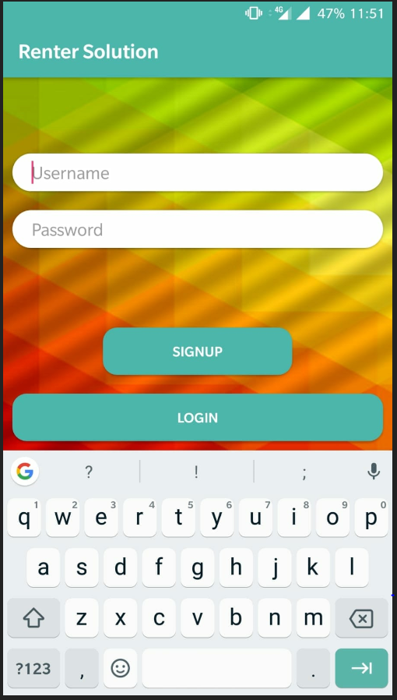

**Figure 25: Login Page view and incorrect credentials**

* **Signup Page**

If someone is new to application and want to register himself for first time, the person must sign up. In signup class we are using signup.php API for storing the new user data into the server. Moreover, in signup view there are two mandatory fields without which the signup cannot be proceeded further. First one is PSR Number for agents and address for tenants. Before signup user must select a category such as tenant, Landlord, or Agent. Figure **26 and 27** shows the image for signup view of all users:

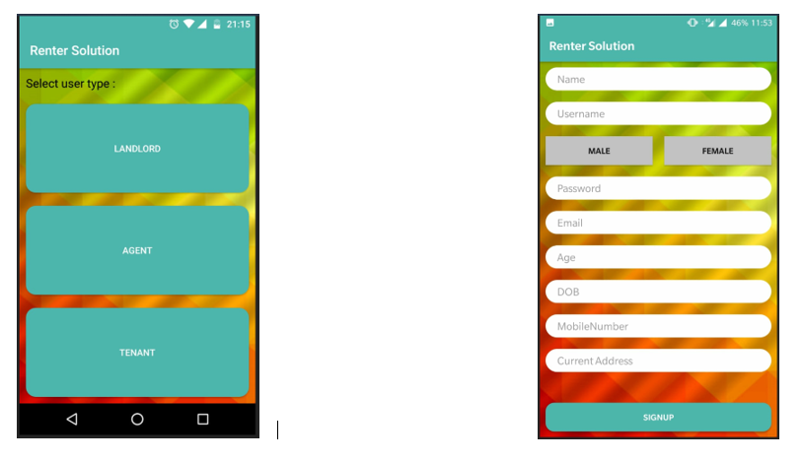

**Figure 26: Select User-Type and Signup for Tenant**

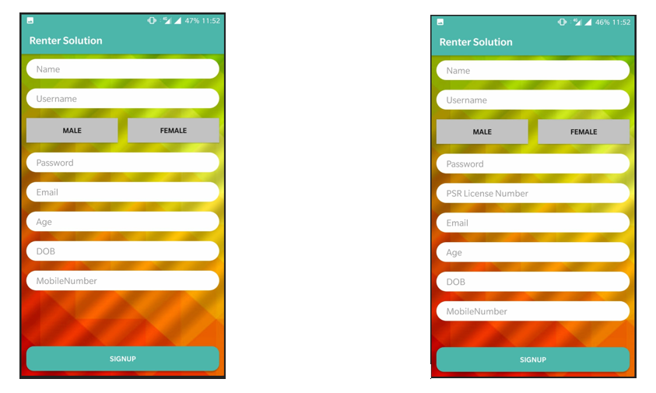

**Figure 27: Landlord Signup (Left) and Agent Signup (Right)**

* **Create Group:**

After successfully signing up, user needs to be enrolled in group for the actual use of application. The concept of group is to make interaction between all users i.e. agent, landlords and Tenants. For every house or apartment on rent there should be a group in which all the tenants and landlords should be added by agent. Practically, agent and landlord can be added in many groups, but a tenant can only be present on one group. To add group in server addGroup.php API is used. Figure **28** show the create group page and asking name of the new group.

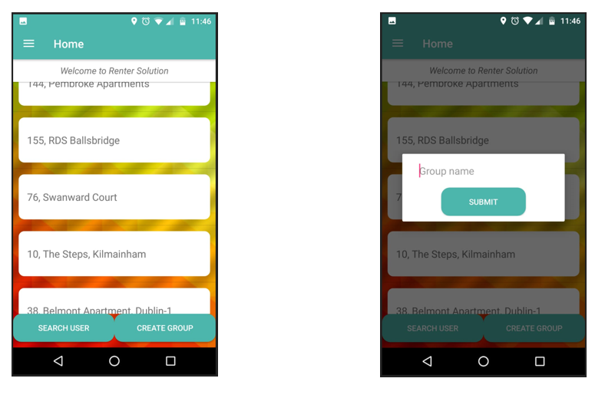

**Figure 28: Create group option only by Agent**

* **Main Page:**

After login, the control will pass to main page (Home) view. All the chat groups in which user is enrolled are displayed on the main page. User can select any chat group and he/she can write any message there. Figure **29** show the chat list on main page of all the users.

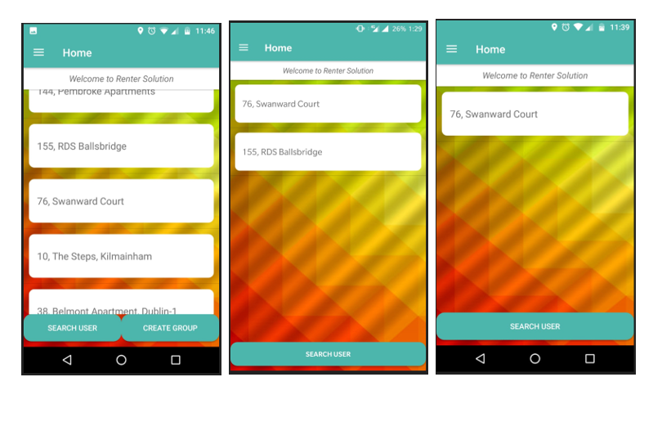

**Figure 29: Main page of Agent (Left), Landlord (Middle) and Tenant (Right)**

* **Chat:**

In chat, two APIs are used which are putData, getData, and putImage. User can send and receive text messages and send images on the group. Figure **30** shows the chat screen and communication between the users.

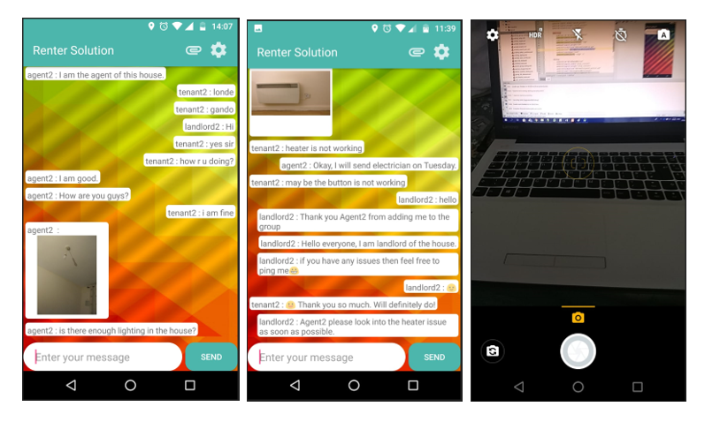

**Figure 30: Communication between landlord, agent, and tenant**

* **Get user details and Rating the user:**

This application provides important functionality to search and give ratings to any user in a group. To search and add rating to a user in the database, “addRating” and “getUserDetails” APIs are used. Figure **31** shows searching and rating view.

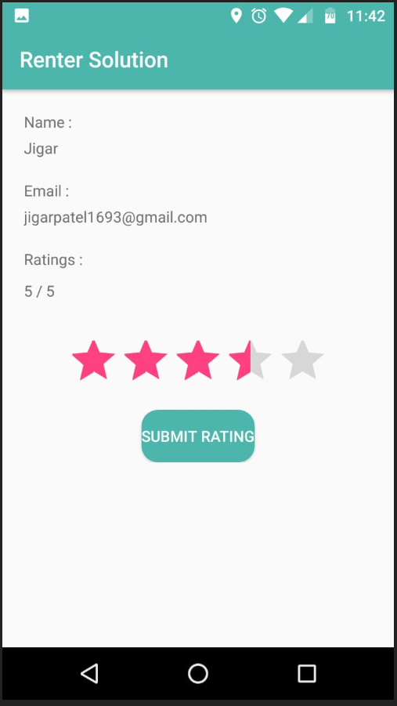

**Figure 31: Search and submit Rating to the user**

* **Search, Add, and Remove:**

Every user present in the group can search, add, and remove users from the group. To search user in the database, getUserList API is used. Moreover, to add user in the group “addUser” API is used and to remove user from the group “deleteUserfromGroup” is used. Figure – shows all functionality.

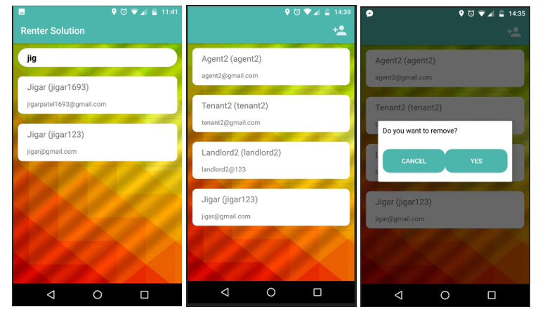

**Figure 32: Search User (Left), Add User (Middle), Remove User (Right)**

1. **Limitation of Implementation:**

**Chapter 5**

**Data Analysis and Findings:**

1. **Introduction:**

This chapter will display the outcomes of the survey that are related to the research. Data analysis is the study of the data collected through primary and secondary data collection sources. The secondary source of the data collected is already explained in Chapter 2 that is literature review, which shows existing theories related to this study. The primary data collection sources are with the help of Questionnaire and Audio interviews taken from targeted audience. In this research, the type of research method used to collect primary data is Qualitative. This chapter is further divided into two sections, first will be survey results, and other will be the experiences of the respondents related to this study.

1. **Survey Results:**